1.What is SDLC?

* Software Development Lifecycle(SDLC) is cost effective and time efficient process that Development team or company can use to develop(build) and design high quality software product as per customer’s requirement.
* SDLC is classical process of software development from planning to product
* It is step by step process by collecting client’s requirement collection, Analysis, Design, implementation, testing to maintenance and support.
* Methods are varies from industry to industry but standard steps are as below :-

|  |  |
| --- | --- |
| Requirements collection | Documentation of customer needs and requirements. |
| Analysis | Model and analysing specify requirements of customer which is well documented |
| Design | Design model to specify solutions. |
| implementation | Construct a solution in software |
| Testing | Validate solutions against customer requirement. |
| Maintenance | Repair defects and adapt solutions to new requirement. |

2. What is software testing?

* Testing is process to evaluating system or its component in intend to find that it satisfied specific requirements or not.

Or Testing is process to identify correctness completeness and quality of developed software program

3. What is agile methodology?

* Agile model is a combination of iterative and incremental model and spiral model.
* Agile model focuses on process adaptivity, quality and customer satisfaction by rapid delivery of working software development product.

Working:

* agile model breaks the product into small incremental builds.
* This build provides iteration.

(Iteration: - process of testing repeating again and again)

* Each incremental build task given to separate team member which will simultaneously work on his build by planning analysing design implementation testing etc….
* At the end deployed to customer.

4. What is SRS (software requirement specification)

* SRS is document that describe requirements of customer and behaviour of system to be developed.

5.What is oops

* Oops is object-oriented programming system which is like a black box testing where internal details are hidden
* Main purpose to deal with real word entity using programming language

6. Write Basic Concepts of oops

1. Class
2. Object
3. Encapsulation
4. Inheritance
5. Polymorphism
6. abstractions

7.What is object

* object is an instance of class that execute the class

8. What is Class

* Class is combination of data members (variables) and number function (process method) with its behaviour

Example: dial 114 number and zee news opens …here 114 number is address of data it is called variable …variable is 114

And news channel opens is called member function (process method).

9. What is encapsulation

* Process of wrapping data and behaviour of object into single unit.
* Unit here is class(interface).

Example: medical capsules process. small objects of medicine placed in capsule as per their behaviour of working.

10. What is inheritance

Definition: New constructed class has access of all the features and properties of existing class(old class) also more function added called inheritance

* Properties of parent class extended into child class.
* Properties of super class extended into sub class.

Example: here super class is old class and it has 3 feature and sub class is new class which has access of 3 features from old (existing)class + more function ..that is called inheritance.

Sub class is extended version of super class

* Main purpose : reusability , extendibility.

11. What is polymorphism

* Polymorphism same object different behaviour.
* Ability to take one name having many form or multiple different form.
* Two types:

1. Method overloading (compile time)
2. Method overriding (run time)

12. Draw Usecase on Online book shopping 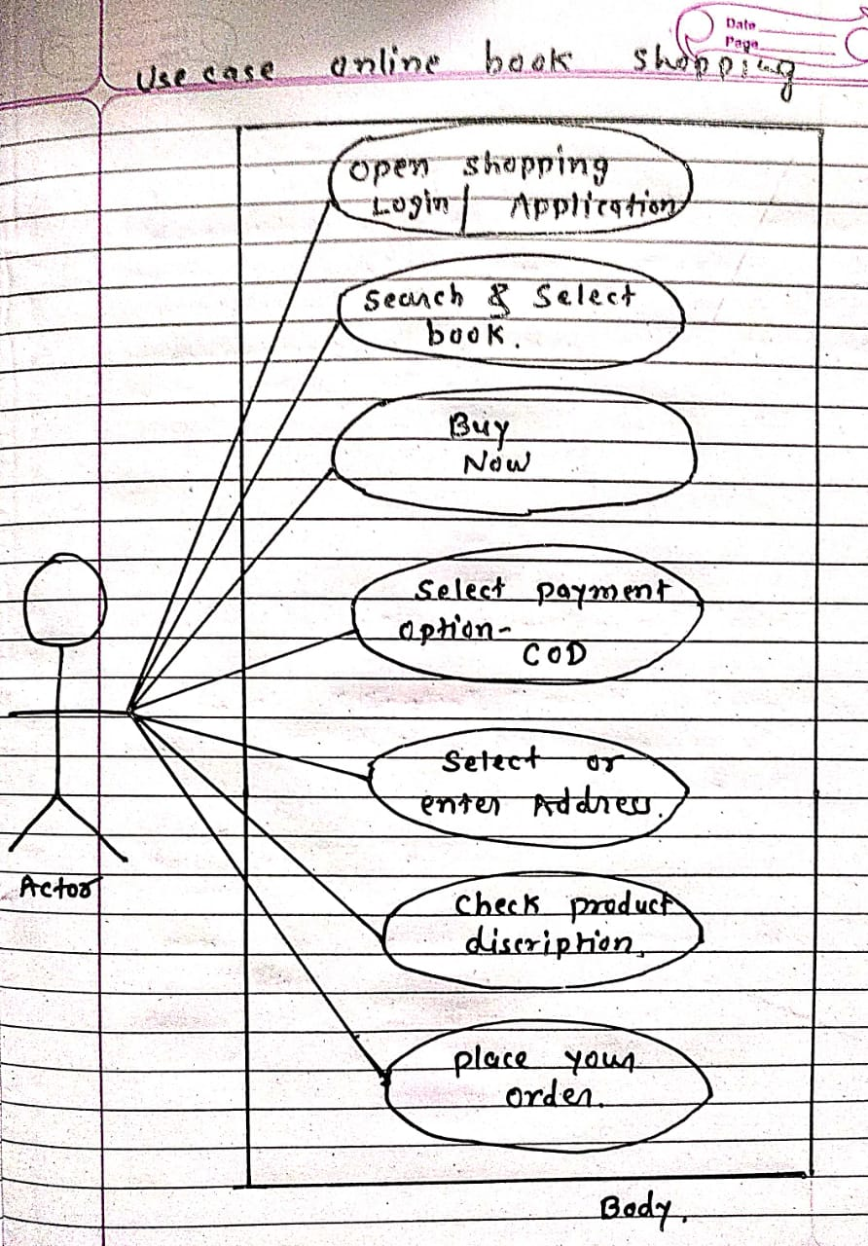

13.Draw Usecase on online bill payment system (paytm)

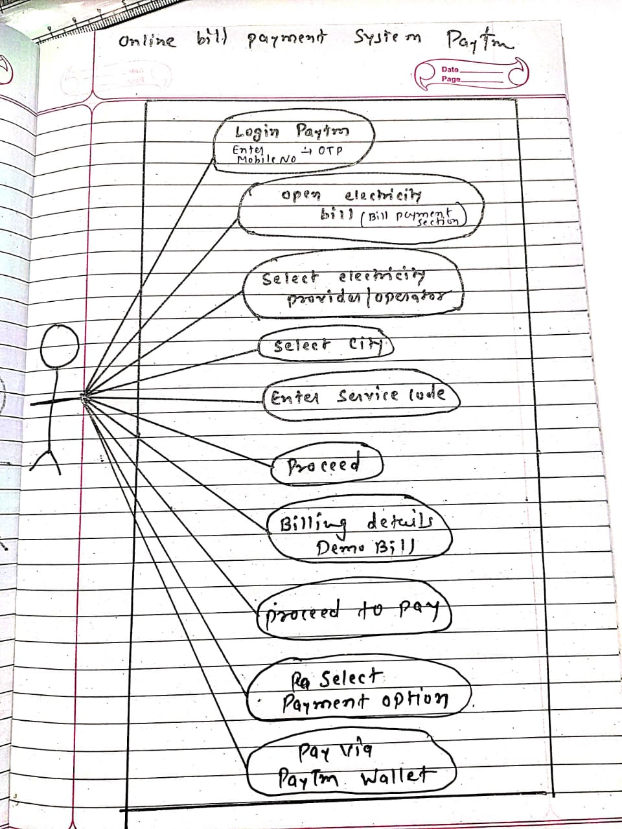

14. Write SDLC phases with basic introduction

* Software Development Lifecycle(SDLC) is cost effective and time efficient process that Development team or company can use to develop(build) and design high quality software product as per customer’s requirement.
* SDLC is classical process of software development from planning to product
* It is step by step process by collecting client’s requirement collection, Analysis, Design, implementation, testing to maintenance and support.
* Methods are varies from industry to industry but standard steps are as below :-

|  |  |
| --- | --- |
| Requirements collection | Documentation of customer needs and requirements.  Types of problem can arise :   1. Lack of clarity-it is hard to write documents that both are precise and easy to read. 2. Requirements confusion- functional and non-functional requirements tend to be intertwined. 3. Requirements Amalgamation-several different requirements may be expressed together. |
| Analysis | Model and analysing specify requirements of customer which is well documented |
| Design | Design model to specify solutions. |
| implementation | Construct a solution in software |
| Testing | Validate solutions against customer requirement. |
| Maintenance | Repair defects and adapt solutions to new requirement.  Types: -   1. Corrective maintenance-identifying and repairing defect 2. Adaptive maintenance-adapting the existing solution to new platforms. 3. Perfective maintenance- |

15. Explain Phases of the waterfall model

* Waterfall model is step by step model which follow step by step phases of software lifecycle
* Requirements are frozen.
* Used for short term project.

Pros: -

1) simple easy to use

2) good for short term project

3) requirements are fixed

Cons: -

1. High amount of risk and uncertainty
2. Poor model for long project.
3. Not possible for Changing requirement

two phases of waterfall model: -

1. verification phase: before the launch it is called verification.
2. validation phase: after the launch it is called validation.

16. Write phases of spiral model

* Spiral model was widely used in software industry as it is sync with natural development process of any product sync with minimum risk involvement

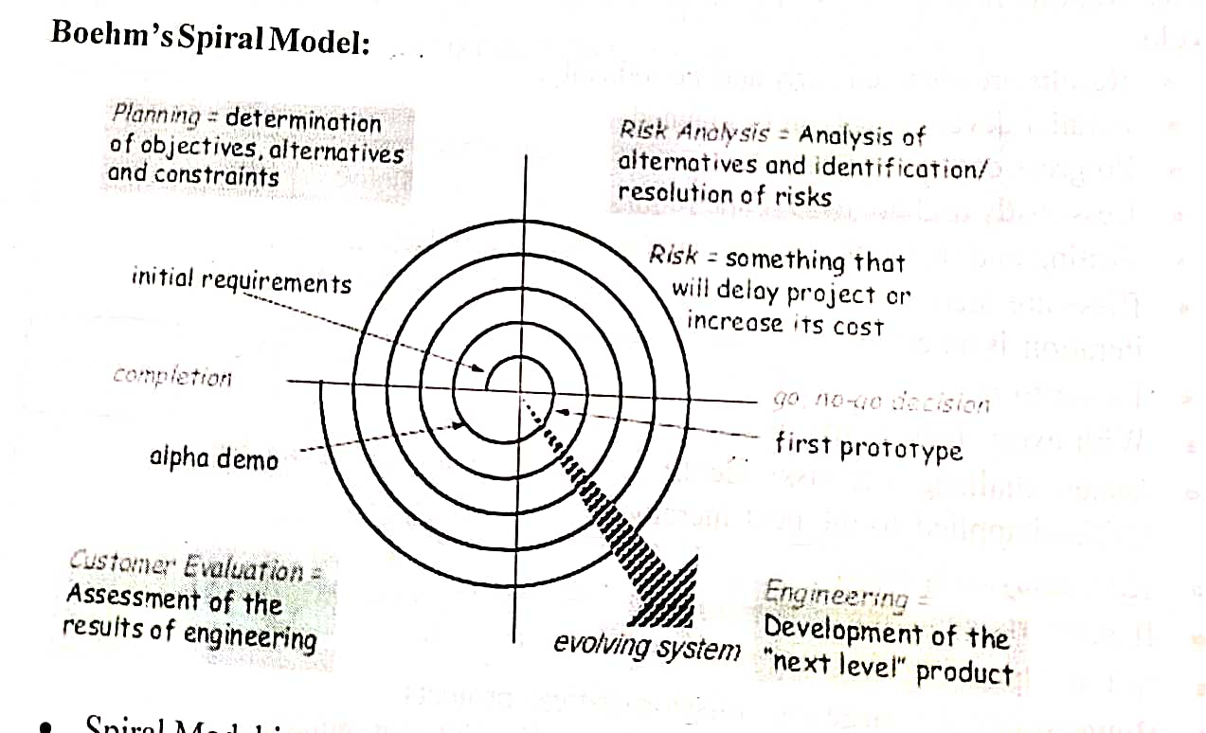

Planning:

* First documentation done as per client’s requirement.
* Team documents initial requirements of product

Risk Analysis:

* Risk analysis for project includes it will fulfil the requirements in budget or not.
* if there are some changes in future or delay of product will increase the cost means increase the budget.
* According to both parameters as above risk analysis is to be done and go for GO-NO GO DECISION.

Engineering:

* Process of development of product by developer team.
* First prototype: Making of development software product by coding by fulfilling initial requirements of client.
* After prototype process of development of product to next level starts.

Customer Evaluation: assessment of the result of engineering.

* In this phase customer involves.
* Alpha demo: demo of development software product given to customer
* If customer add or change the requirement process again go back for development process.
* This process can go to infinitely.
* When alpha demo satisfied customer and fulfil all initial requirement also other requirements and changes then it is completion of product.

17. Write agile manifesto principles.

* individual interaction: separate task to separate team member to complete project in time
* working software
* customer collaboration: - negotiation with customer.
* responding to change: requirements should be change on time and rapidly.

18. Explain working methodology of agile model and also write pros and cons.

* Agile model is a combination of iterative and incremental model and spiral model.
* Agile model focuses on process adaptivity, quality and customer satisfaction by rapid delivery of working software development product.

Working:

* agile model breaks the product into small incremental builds.
* This build provides iteration.

(Iteration: - process of testing repeating again and again)

* Each incremental build task given to separate team member which will simultaneously work on his build by planning analysing design implementation testing etc….
* At the end deployed to customer.

Pros: -

* Widely used in industry.
* Development is rapid.
* Suitable for changing and fixed requirements.
* Well-planned model gives flexibility to developers.
* Suitable for long project.

Cons: -

* High risk for sustainability ,maintainability , and extensibility.
* Very highly individual dependency and Minimum documentation
* Complex method it needs strict and well management.

19. Draw use case on Online shopping product using COD.

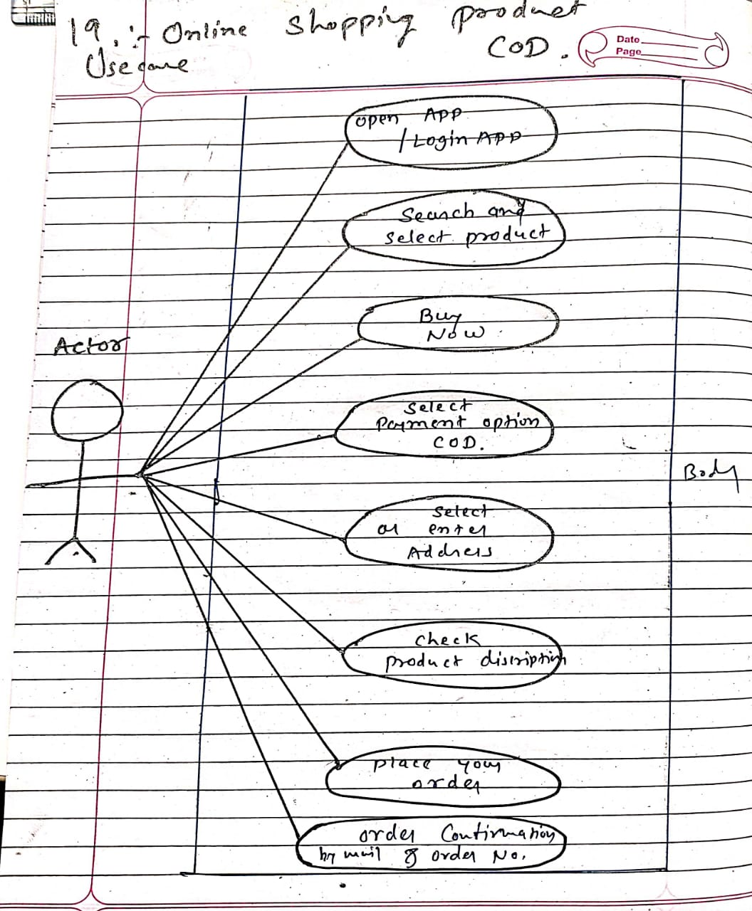

20. Draw use case on Online shopping product using payment gateway

